**Cariboo Lake Results Draft**

By Alex Cebulski

Sept 7, 2020

Revision 2

**Sub-bottom Acoustics**

Acoustic stratigraphy from six selected transects conducted across Cariboo Lake reveal the range of morphologies and character of sedimentary deposits in Cariboo Lake (Fig. 2). Acoustic penetration is limited in coarser sediments from transects proximal to river fan-deltas across Cariboo Lake (see Fig. 1 for fan-delta locations). Penetration, resolution and distinctive acoustic layering improves significantly along the thalweg of the lake bottom and in cross-lake transects more distal from the fan-deltas. Cross-hatching is observed over most of the acoustic record due to errant electrical interference from the research vessel. However, the interference does not affect the overall quality of the results in the six selected transects.

Transect A, one kilometre southwest of the headwater Cariboo River delta, has a strong acoustic reflector at the sediment-water interface indicating the presence of courser-grained material on the lakebed (Fig. 3, A). A high fraction of sandy materials in this transect act as an acoustic mask limiting the penetration of the acoustic signal to a depth of 1-2 m. An acoustic multiple (echo) is observed 45 m below the sediment surface caused by the limited penetration at the surface (Fig. 3, A - i). Acoustically penetrable, well-layered sediment is observed 3.5 km from the Cariboo River delta in transect B (Fig. 3, B). Acoustic reflectors with 1-2 m spacing lies conformably over a hummocky basement, with a maximum observable sediment thickness of 15-20 m observed near the thalwag. Well structured layering extends across the south side of the transect but pinches out towards the north shore (Fig. 4).

Acoustic penetration increases in locations about 4.5 km from the Cariboo River delta at transect C (Fig. 3, C). The acoustic record along this transect reaches a maximum sediment thickness of 35 m in two troughs - the maximum thickness of surficial sediments observed across Cariboo Lake in this study. The acoustic basement is considered to be either bedrock or coarse-grained glacial sediment from the Last Glacial Maximum (Fig. 3, C - i. Two sediment facies are observed across this transect based on geometry and the strength and continuity of reflectors. Some disruption of these facies is caused by slumping of side slopes (e.g. north end of transect C). The lower unit, facies A, has a thickness of ~ 12 m along undisturbed sections (Fig. 3, C - A) and is more massive to weakly acoustically layered. The contact with overlying sediment above facies A appears to be conformable at the south end and middle of the transect but unconformable in other places. The unconformities are most apparent in the two sharp crested v-notch channels at the middle of the transect. These are inferred to be scour channels formed by erosive, higher energy, turbidity currents that probably date to deglaciation of the lake basin. The lack of numerous layers and generally lighter grey tone in facies A indicates a somewhat higher energy and more rapid deposition of coarser lacustrine sediment.

Facies B begins with high-amplitude parallel reflectors with 2-3 m spacing and conforms well to facies A below, outside of areas of disturbance. (Fig. 3, C - B). Facies B has a thickness of ~ 10 m along undisturbed sections and deepens to a maximum of 13 m within the scour channels (Fig. 3, C - ii & iii). The strength of reflectors in facies B are stronger and more numerous than those in facies A indicating more frequent events of lower overall magnitude during this time period. The strength of reflectors gradually decreases moving upwards and spacing thins to sub metre near the surface. The gradual decrease in reflectance is interrupted by a strong reflector at the top of facies B along the sediment-water interface.

The two buried troughs in transect C (Fig. 3, C - ii, iii) are significant and only well expressed in this area of the lake. The north trough (ii) appears to be a depression what was continuously infilled by facies A and then B. Hence it is and older pre-existing feature. The sediments in the southern trough (iii) are interesting in that a wedge of sediment infill seems to be an unconformable deposit with both facies B below and facies A above. It is likely that an erosional channel developed after or in the later stages of facies A deposition which infilled with the wedge. Sedimentation of the wedge was then truncated by the onset of the facies B sediment. While the two troughs might have been active at the same time during deglaciation, only the southern trough was reactivated at a later time and infilled with sediment prior to the onset of facies B deposition.

Transect D, to the northeast of the Frank Creek delta has well-layered sediments in the top 5-10 m and transitions to poor acoustic penetration below this (Fig. 3, D). The parallel reflectors observed in the uppermost sediment layers of transect D have a thickness of 2-3 m and have a higher amplitude compared to facies B in transect C. Some slumping of sidewall sediments is observed on the south sidewall (Fig 6, i)

Southwest of the Frank Creek fan-delta, acoustic reflectors along transect E show a decline in reflectance and a decrease in layer thickness to < 1 m. Acoustic masking from course grained sediment occurs at depths of 2-4 m along the south margin (Fig. 3, E). Total sediment thickness of finer, well acoustically layered, material along the north bench is significant approaching 10 m. The sedimentary environment southwest of the Frank Creek delta is comparably different to transects northeast of the delta. The profile suggests that much of the suspended sediment transported from the upper lake does not make it past the shallow lake depths (< 20 m) of the sill at the Frank Creek fan-delta apart from the northern most part of the transect. So, coarser sediment from the Frank Creek fan-delta dominates the south side of the transect and fine sediment deposition is restricted, or forced, to the north side. The coriolis effect may enhance this as suspended sediments are deflected to the right as they enter Cariboo Lake from Frank Creek.

Similar to the Frank Creek fan-delta, the very shallow sill of less than 2 m opposite the Keithley Creek prograding fan-delta significantly reduces sediment connectivity to the main Cariboo Lake basin. (Fig. 1). Transect F, located close to the centre of the Keithley Creek sub-basin shows a maximum observable sediment thickness of 4 m concentrated in the basin thalweg (Fig. 8). Below this there is acoustic masking by coarser grained sediment. The acoustic reflectors within the top 4 m of transect F are acoustically penetrable, well layered and are conformable to the basin morphology. These reflectors are of higher amplitude compared to those in transect E and are thicker at 1-2 m. This suggests that significant amounts coarse-grained sediments are found in this part of the lake, likely originating from the high energy Keithley Creek drainage basin. While fine faction sediments from the main Cariboo Lake are expected to make up a small percentage as transport is limited by the Keithley Creek fan-delta.

Spatial Trends

Spatial variation in surficial sediment laminae, grain size, and organic content were analyzed from Ekman bulk samples ranging from 6-12 cm thick (Fig. 4, *n* = 20). Proximal to the Cariboo River delta (< 500 m) the structure of the surficial sediments exhibit massive layering, erosive contacts and the fraction of sand grains in these samples exceeds 60 % (Fig. 5). A sand bed with a thickness of 1 cm is observed in the bulk sample closest to the Cariboo River delta (Fig. 6, A). At distances greater than 2 km from the Cariboo River delta the fraction of silt grained sediments increases to over 80 % and rhythmic laminations are observed (Fig. 6, B). However, proximal to the Frank Creek delta an increase in coarser grained sediments is observed and as a result these cores did not exhibit regular laminae structures (Fig. 5). In the Keithley Creek basin the laminae structures are very distinct and are larger in size than those observed in the main Cariboo River basin (Fig. 6, C).

Statistics calculated on the thickness of sediment laminae demonstrate a gradual decreasing trend with distance from the Cariboo River delta (Fig. 7). Maximum varve thickness has an average of 4.7 mm (*n* = 6) in the Cariboo River basin and 7.9 mm (*n* = 3) in the Keithley Creek basin. Maximum varve thickness decreases by 0.62 mm/km in the Cariboo River basin and by 2.17 mm/km in the Keithley Creek basin (Fig. 7). This decrease in laminae thickness with distance from the delta is likely due to the Cariboo River being the main source of sediment into Cariboo Lake and sediment flux typically declines with distance from the primary sediment source. The decline in thickness is steeper in the Keithley Creek Basin likely due to additional local inputs of coarser grained sediment coming from the Keithley Creek tributary which are not transported as far as suspended sediments.

Within the main Cariboo Lake basin, D50 grain size follows a steep decline from 89.9 μm 300 m from the delta to 31.3 μm 550 m from the Cariboo River delta (Fig. 7). A small increase in D50 is observed proximal to the Pine Creek delta up to 28.2 μm, 1.83 km from the main Cariboo River delta (Fig. 7). Further down lake the decline in D50 grain size continues more gradually to 7.9 μm 6.4 km from the delta (Fig. 7). Proximal to the Frank Creek delta the D50 grain size nearly doubles in size to 15.1 μm at 7.35 km from the Cariboo River delta. Across the Keithley Creek basin the D50 grain size has an average of 15.9 μm (*n* = 3).

The increase in D50 an

A return to primarily silt and clay grain sizes is observed with 86.5 % silt, 12.2 % and 1.3% sand at 3.65 km from the Cariboo River delta. (Fig. 7).

Lithostratigraphy

Discussion:

Sub-bottom: The generally homacky basement of sediment across cariboo lake indicates the generally undisturbed layering of suspended sediment across the lake bottom. transect b bottom facies not as reflective so doesn’t show up in deepest part of the basin. Bottom part of transect b and others is light in colour which is less reflective and is indicative of clastic-poor sediments which is expected during the warming period of the early Holocene. Evidence of early Holocene warming and glacial retreat is provided by various studies in the south Coast (Menounos et al., 2004; Osborn, Menounos, Koch, Clague, & Vallis, 2007; Koch, Osborn, & Clague, 2007) however some evidence of glacial advance in the Rockies has been found although the legitimacy of these radio carbon dates have been questioned in the Rockies (Menounos et al., 2009).

transect D observes an incrwase in acoustic masks due to proximity to the frank creek delta. This is why there is less penetration on the south slope compared to the centre transect. The proximity to the Frank Creek delta here also ecplains the increase in strength of paralell reflectors due to an increase in strength of turbidity currents from Frank Creek.

The small catchment size of Pine Creek along with the grain size record shown here suggest Pine Creek inputs are localized and down-lake sediment supply is dominantly provided from silt and clay grain sediments deposited by suspended sediment transport from the Cariboo River.

**Figures**

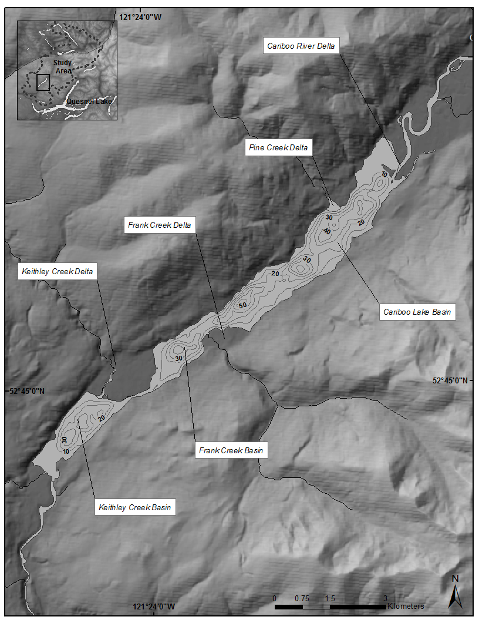

**Figure 1:** Cariboo Lake bathymetry. Contour interval is 10 m.

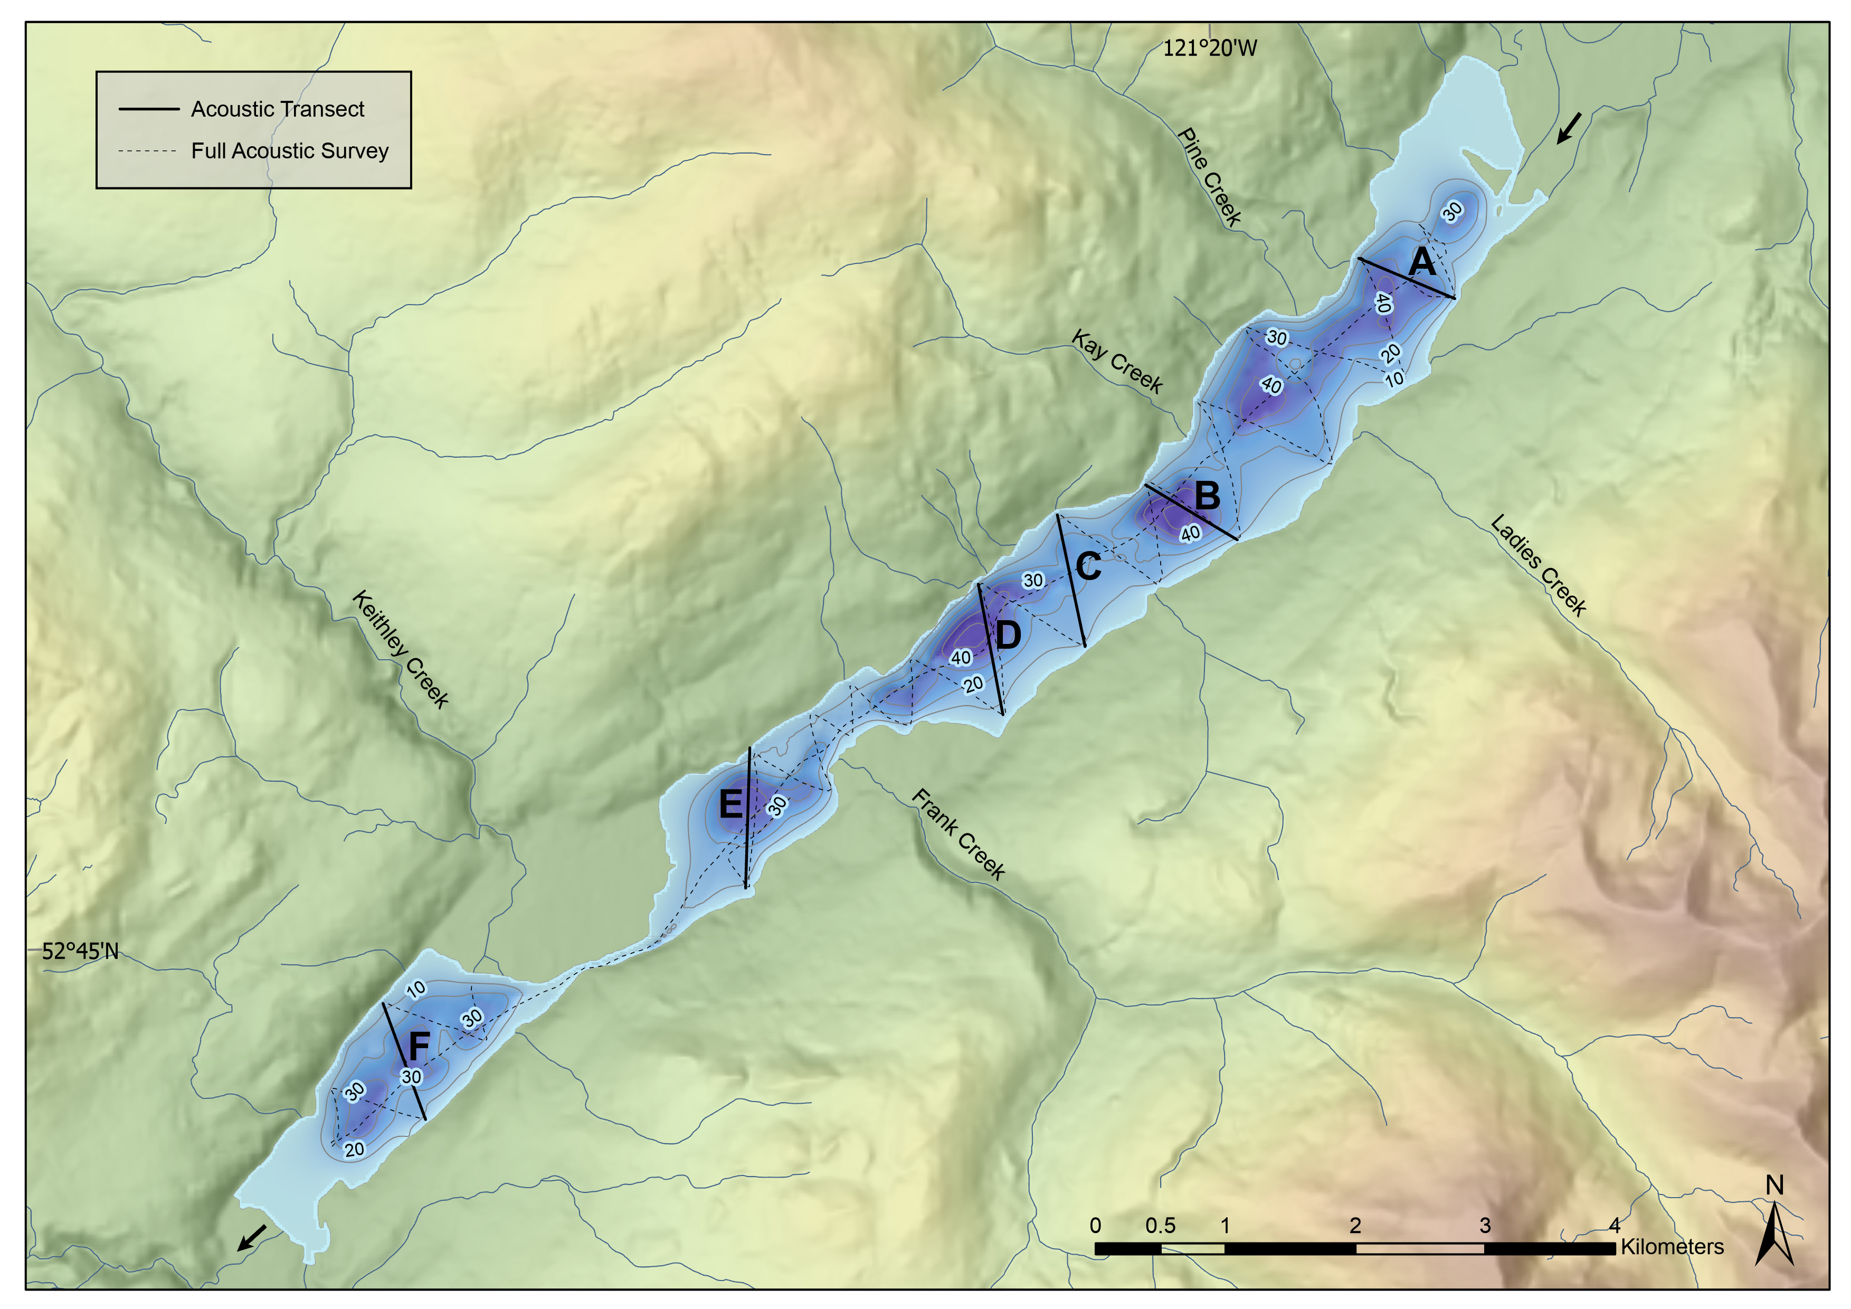

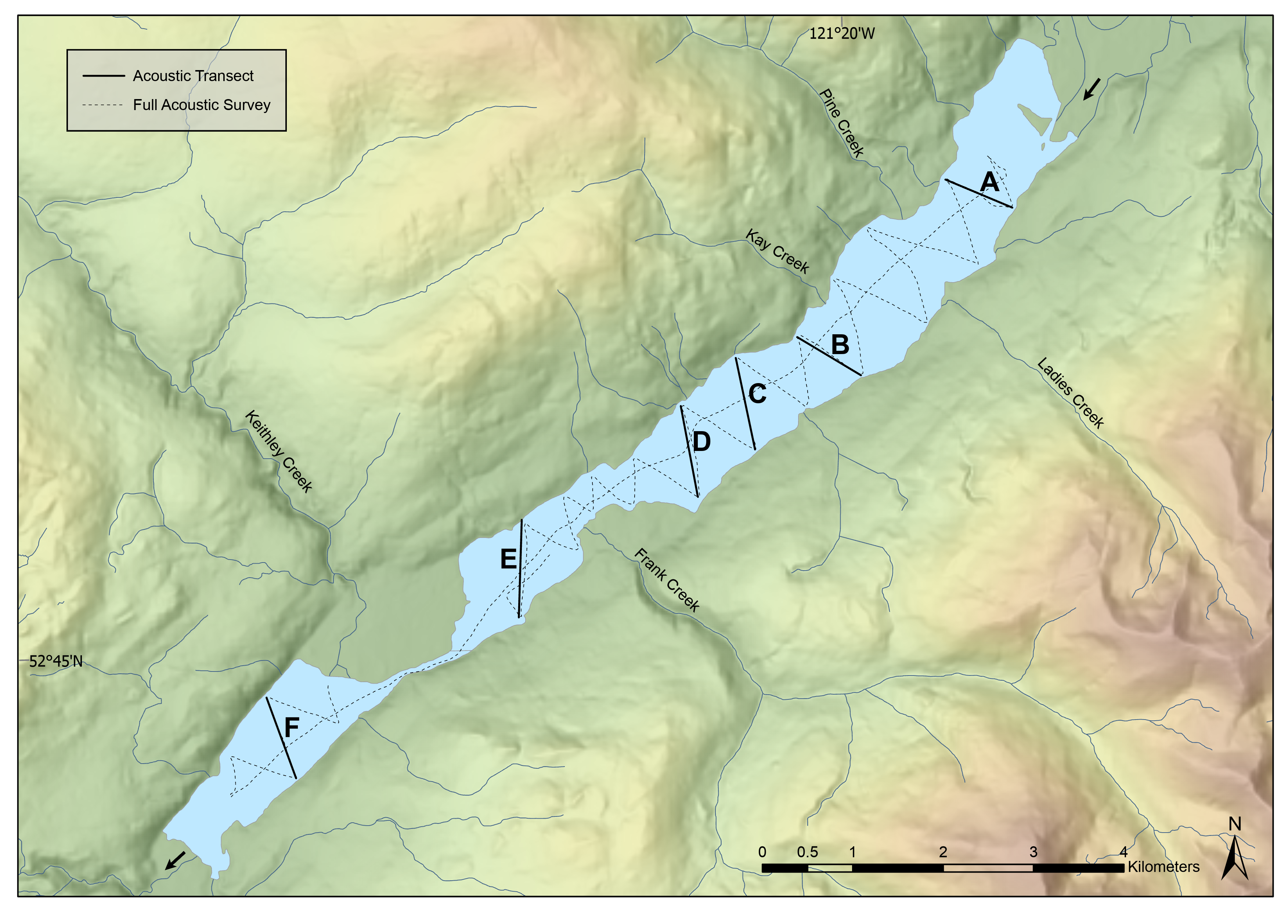

**Figure 2**: Cariboo Lake sub-bottom acoustic transects with six selected transects labelled and shown as bold black lines. Note: inflow to Cariboo Lake is from the northeast end and exits to the southwest.

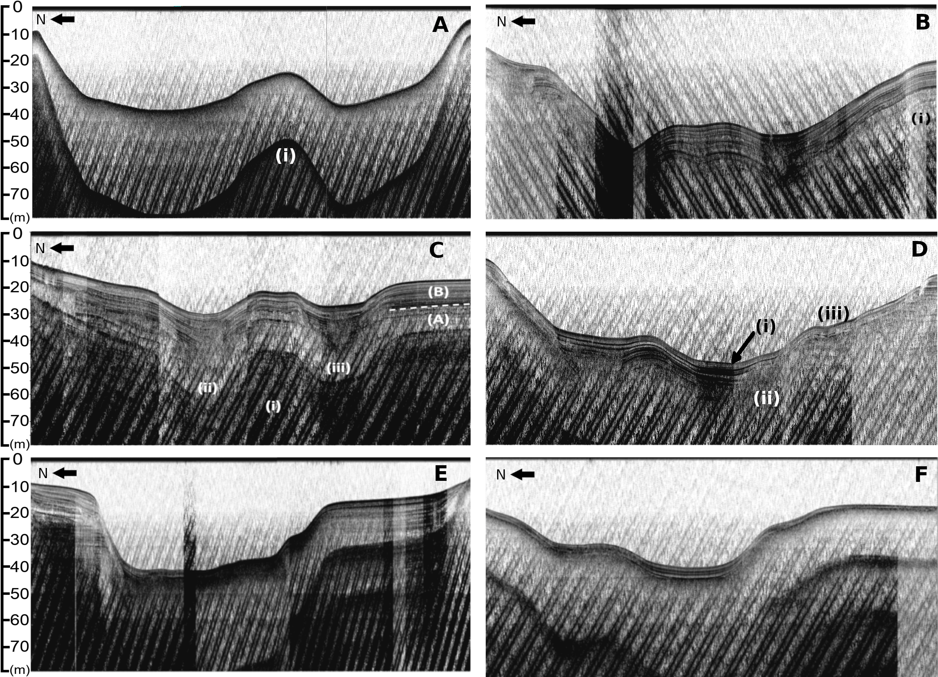

**Figure 3:** Panel of six selected sub-bottom acoustic transects A, B, C, D, E, and F. All transects are looking up-lake, see Fig. 2 for location. Transect A & B: Acoustic echo (multiple) is denoted by (i). Transect C: (i) denotes inferred bedrock or late-glacial material. (ii) and (iii) are v-notch scour channels. (A) and (B) are sediment facies. Transect D: Scour channels are denoted by (i) and (ii). Slumping is observed at (iii).

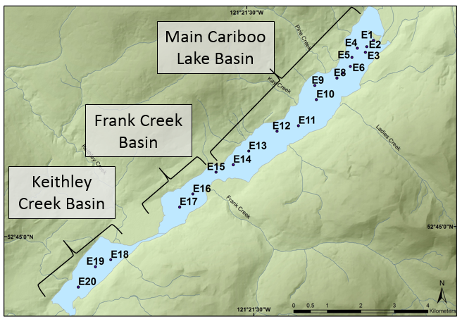

**Figure 4:** Ekman bulk sample locations. Sub-basins denoted by text boxes.

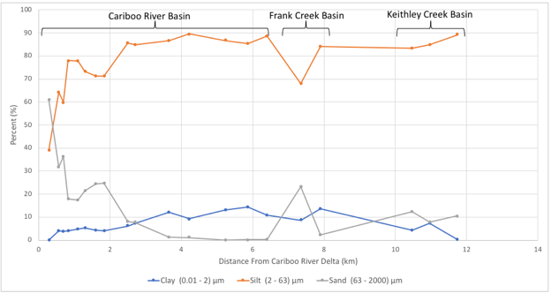

**Figure 5:** Ekman bulk sample percent composition of clay, silt, and sand sized particles versus distance from Cariboo River delta.

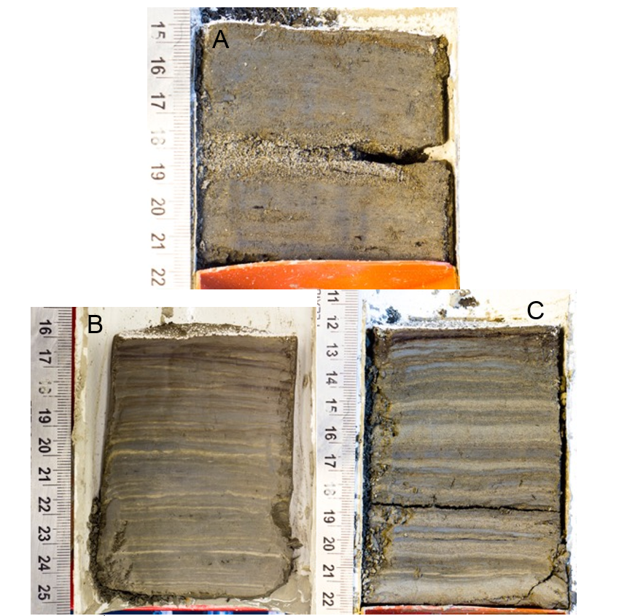

**Figure 6:** Selected surficial Ekman sediment core photographs. A (E1) is proximal to the Cariboo River delta. B (E13) was retrieved from the second deepest basin in the lake in the Cariboo River basin. C (E18) was retrieved from the Keithley Creek basin.

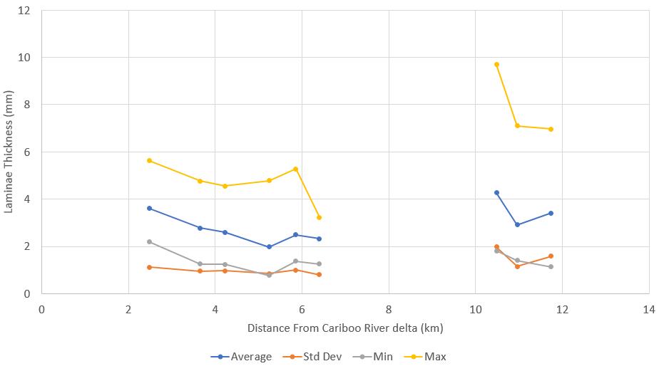

Keithley Creek Basin

Cariboo River Basin

**Figure 7:** Laminae Statistics calculated on surficial Ekman cores E9-15 and E18-E20.

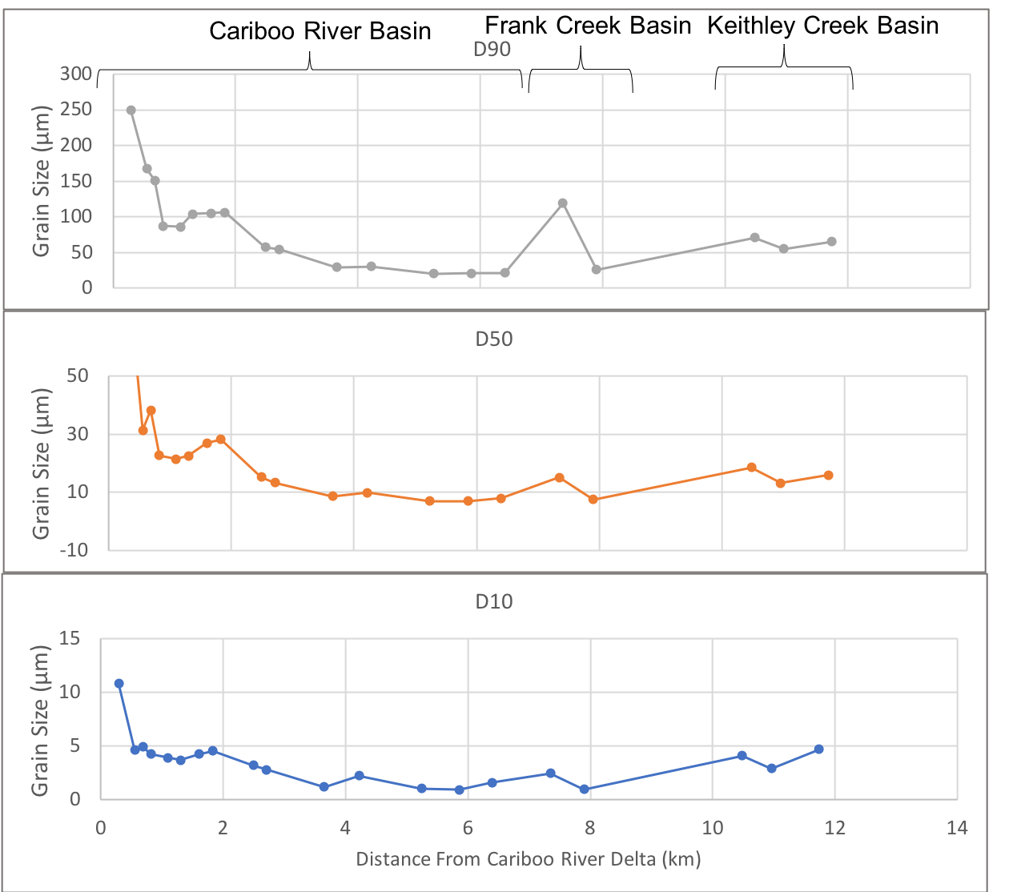

**Figure 8:** Ekman bulk sample grain size diameter versus distance from the Cariboo River delta. (A) D90, (B) D50, (C) D10.